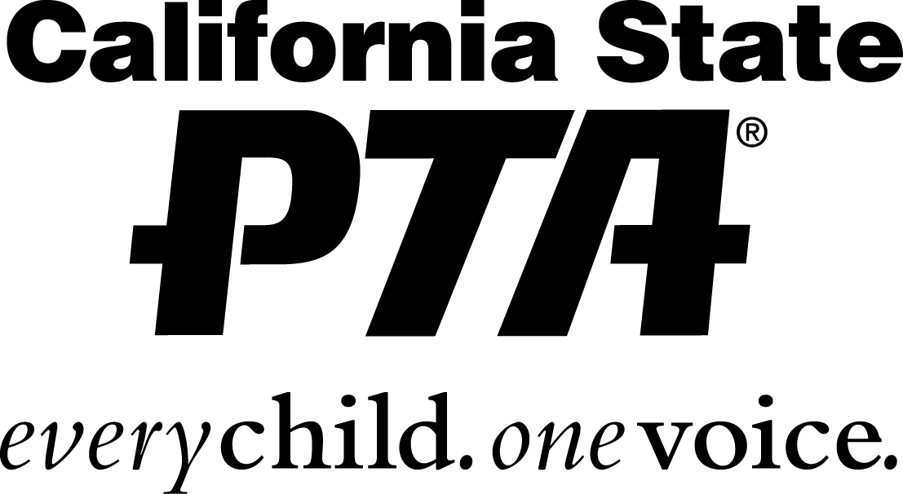 | PARENT’S APPROVAL, STUDENT, FAMILY, AND PARTICIPANT WAIVER  Each family MUST have a signed waiver in order to participate  in PTA events. Complete one form per family. Please print clearly.
2327 L Street, Sacramento, CA 95816-5014 (916) 440-1985 • FAX (916) 440-1986 • Email info@capta.org • www.capta.org

Print the name of all family members who may participate in any PTA sponsored events for the 2018 -2019 school year (including student, siblings and parents):
1.
Participant Name Age, if minor child
2.
Participant Name Age, if minor child
3.
Participant Name Age, if minor child
4.
Participant Name Age, if minor child
The undersigned parent(s) or guardian(s) assume all risks in connection with the participation of all individuals listed above in any and all of the PTA sponsored activities.

I attest and verify that all individuals listed above are physically fit and able to participate in any PTA sponsored activities. Further I acknowledge that is it my responsibility to understand any inherent risks associated with PTA sponsored activities and communicate those risks to all individuals named above.

I do hereby certify that to the best of my knowledge and belief all individuals named above are in good health. In the event that I, or other parent/guardian, cannot be reached in an emergency, I hereby give permission to secure proper treatment for my child(ren). I/we do hereby consent to whatever x-ray, examination, anesthetic, medical, surgical or dental diagnosis or treatment and hospital care are considered necessary in the best judgment of the attending physician, surgeon or dentist and performed by or under the supervision of the medical staff of the hospital or facility furnishing medical or dental services. It is further understood that the undersigned will assume full responsibility for any such action, including payment of costs.

I/we hereby advise that the above named minor(s) has the following allergies, medicine reactions or unusual physical conditions, which should be made known to a treating physician: (If none, please write the word “none”. If yes, put first name of child and the allergy/condition.):

I/we, as parent(s) or guardian(s) of the minor(s), do hereby, for my child/children, myself, my heirs, executors and administrators, release and forever discharge and hold harmless the California State PTA, the local PTA and all officers, directors, employees, agents and volunteers of the organizations, acting officially or otherwise, from any and all claims, demands, actions or causes of action which in any way arise from the participation of any individuals listed above in any PTA sponsored activities.

By signing below, I confirm that I have carefully read and fully understand its contents. I am aware that this is a release of liability and signed it of my own free will.
1.
Parent/Guardian Signature Print Name Date
2.
Parent/Guardian Signature Print Name Date

Address City State Zip Phone (incl area code)

